History
NL: Research and explain Ceasar’s invasion of Britain.
 | 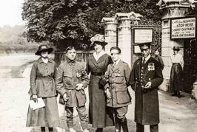
Chronological Understanding | Historical Knowledge | Interpretation of History | Historical Enquiry | Research
Challenge: Name two items they would have traded and why?
STAR words: Invading, trading, Gaul,rebel,rebellion,retreat.

