Key objective: |  | Cross curricular links:
To explore ‘sacred spaces,’ where people use a behaviour different to their normal behaviour. |  | - History  - Art  - Design & Tech
Key knowledge: |  | Progression:
- Behaviour in ‘sacred spaces’ is different because...  - A church is…  - Key features of a mosque are…  - Key features of a peace pagoda are...  - People reflect through... |  | Year before:  Year after:
Key vocabulary:
church  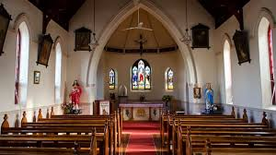 | peace pagoda  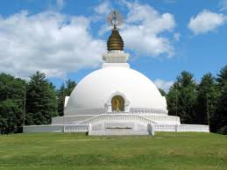 | mosque  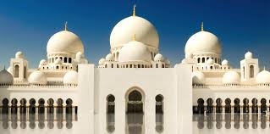 | synagogue  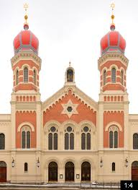
gurdwara  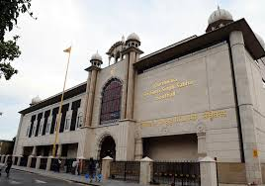 | temple  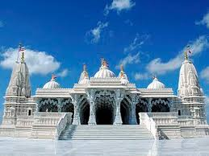 | dome  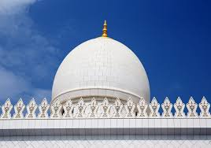 | qibla  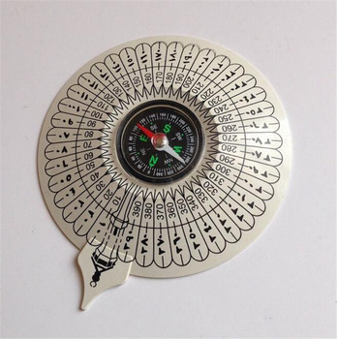
minaret  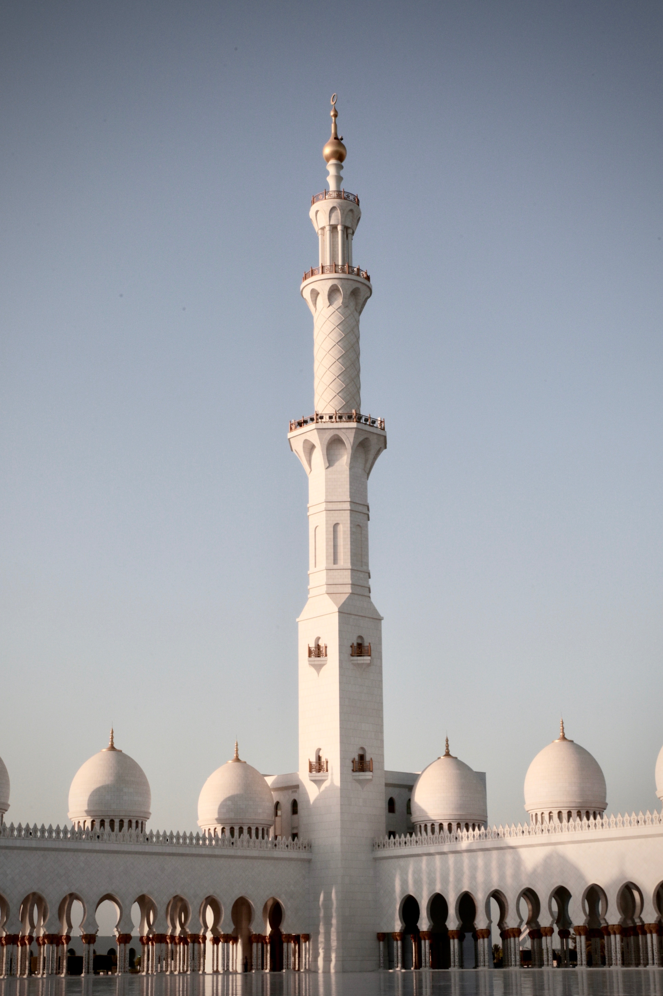 | reflection
Output:
Compare & Contrast  - Comparison chart  - Diary entry  - Design task | Research  - Labelled diagram  - Design task | Express & Respond  - Diary entries  - Graphic organisers | Present & Report  - Information report

